June 6, 2021

Welcome! We are glad that you are here to worship the Lord!
Today we will begin a new sermon series called, “Life’s Landscapes – Navigating Spiritual Geography.”

In this series we will journey to various landscapes in Scripture and see how these relate to our spiritual lives. We will the tour the garden, travel to the wilderness, climb mountains, hike through valleys, cross rivers and lakes, and more. Be sure to travel with us this summer as we explore various landscapes of scripture and the ways they shape our lives.

9:30 A.M. WORSHIP SERVICE

Prelude

Welcome & Announcements

*Call to Worship
*Opening Song: “Praise to the Lord, the Almighty”
*God's Greeting
*Apostles Creed
I believe in God, the Father almighty,
creator of heaven and earth.

I believe in Jesus Christ, his only Son, our Lord,
who was conceived by the Holy Spirit
and born of the virgin Mary.
He suffered under Pontius Pilate,
was crucified, died, and was buried;
he descended to hell.
The third day he rose again from the dead.
He ascended to heaven
and is seated at the right hand of God the Father
almighty.
From there he will come to judge the living and the
dead.
I believe in the Holy Spirit,
the holy catholic* church,
the communion of saints,
the forgiveness of sins,
the resurrection of the body,
and the life everlasting. Amen.
*that is, the true Christian church of all times and all places

*Song: “I Sing the Mighty Power of God”

Prayer
*Song of Preparation: ”Have Thine Own Way, Lord”

Prayer of Illumination
Scripture Passage: Genesis 2:4-17
Message: “Life in the Garden”

Prayer of Application
*Song: “Beautiful Savior”

*Commissioning and Departing Blessing
*Closing Song: “”Glory Be to the Father”
*Moment of Meditation
*Postlude

*Indicates Standing

ANNOUNCEMENTS

Children in Worship today: Kathy & Jenna TerVeen
Next Sunday: Tara Johnson & Natalee Tyink

Nursery Attendants today: Elizabeth Rasmussen &
Gabie Schmidt
June 13 – Sue Tibbe & Alicia Schafer
June 20 – Rebecca Krick & Molly Kooistra
June 27 – Bethany Hooker & Samantha Greer
High Schoolers! Thanks for a fun year! Even though regular FYSH events are over, please look forward to these upcoming events:
- June 30th a fun evening planned!
- July 18 - FYSH Whitecaps @ 6 pm
- August 14 or 21 - (Possible Day on the Lake)
We are in need of help for funeral luncheons, either working at them or baking cakes, cookies or brownies. If you are willing to help, please sign the sheet at the Welcome Center.
We are going to start with “coffee” after the church service soon. If you would be willing to take a turn, please sign up at the Welcome Center. Those who were on the list previously will remain on the list unless they ask to have their name removed.

Do you miss singing the old songs? Saturday, June 12th, 7:00 pm at The Shack will be a Good Old Fashioned Hymn Sing to benefit the Newaygo County Volunteer division of Bible League. Free will offering. Multiple musicians. Contact Christi Handy @ 231-578-5354 or Jessie Rose @ 923-2231.

Father’s Day is the perfect day to honor those who gave us the gift of life. If you would like to thank your Father, Grandfather or any special man for choosing life and nurturing you, place their name on the list at the welcome center and enclose $2.00 for each name. Indicate the living under in Honor Of and those who have passed on under in Memory Of. The names will be printed in the Hi-Lites on Father’s Day by Newaygo County Right to Life. Every life is precious and designed by God.

Elevate Sports Camp is designed for kids entering grades 3-8 and covers a variety of sports. In our first year (2019), we included basketball, volleyball, soccer and baseball/softball. This year we're offering track and field instead of baseball. Using local coaches, participants learn basic skills and drills and then have an opportunity to engage in some competition using those new or refined skills. We also include a faith component and challenge participants with a short Bible lesson and small group time. Registration is open at https://www.firstcrcfremont.org/sports-camp or call the church office for more information (231) 924-2460.

Reeman Christian Reformed Church

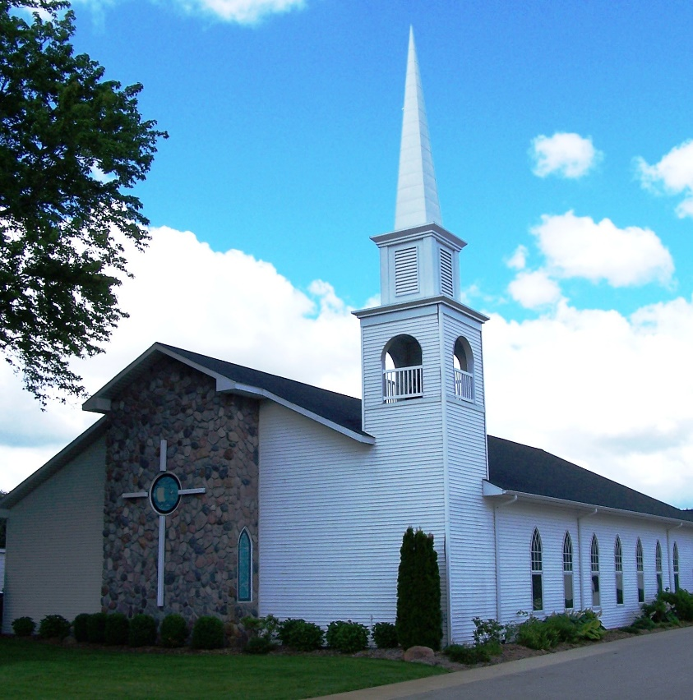

As a part of God’s family
We strive to show Christ’s love to all
For the glory of God

Pastor Les Van Dyke
Pastor Nate Kooistra

