June 27, 2021

Welcome! We are glad that you are here to worship the Lord!
Today we will continue our series called, “Life’s Landscapes – Navigating Spiritual Geography.”

In this series we are taking a journey to various landscapes in Scripture and see how these relate to our spiritual lives. We have visited the garden of Eden, the River of Life and Valleys. Our message today is called “Wilderness: The Land Between.”

Prelude
Welcome and Announcements

Call To Worship
*Opening Songs:
“Glorify Thy Name”
“Majesty”
*God’s Greeting

Confession and Renewal
Congregational Prayer

*Song: “Have Thine Own Way, Lord”
(Children Ages 2-Kindergarten are dismissed for Children’s Worship)

Scripture: Numbers 11:4-17
Sermon: “Wilderness: The Land Between.”
Prayer

*Song of Response: “Lead Me, Guide Me.”
*Departing Blessing
*Song: “Benediction Song”
*Moment of Meditation
*Postlude

*Indicates Standing

ANNOUNCEMENTS

Children in Worship today: Stephanie & Molly Kooistra
Next Sunday: Stephanie & Molly Kooistra

Nursery Attendants today: Bethany Hooker & Samantha
Greer
July 4 – Elizabeth Wolffis & Helen Bowyer
July 11 – Emily Seyferth & Aimee Richards
July 18 – Allie Maat & Gabie Schmidt
July 25 – Elizabeth Rasmussen & Sue Tibbe

Praise Team will practice Wednesday evening at 6:30 p.m.

Thank you to all who attended and lifted hearts and voices at the Old Fashioned Hymn Sing held Saturday evening, June 12th, at The Shack benefiting Bible League International volunteers of Newaygo County! What joyous singing and generous giving which will provide 200 Bibles to eagerly waiting Christians. May it have been a blessed evening for you. Serving our Lord together, Christi Handy & Jessie Rose

An outdoor worship service is scheduled for next Sunday, July 4th, at 9:30 a.m. Bring a lawn chair or blanket for seating. The service will be broadcast at 89.9 if you wish to remain in your vehicle.

Sunday Sundaes fundraiser is back! Following the service on July 18, the Guatemala 2022 team will be serving sundaes with a variety of toppings. Your donations will help to feed needy families in Guatemala.

Reeman Christian Reformed Church

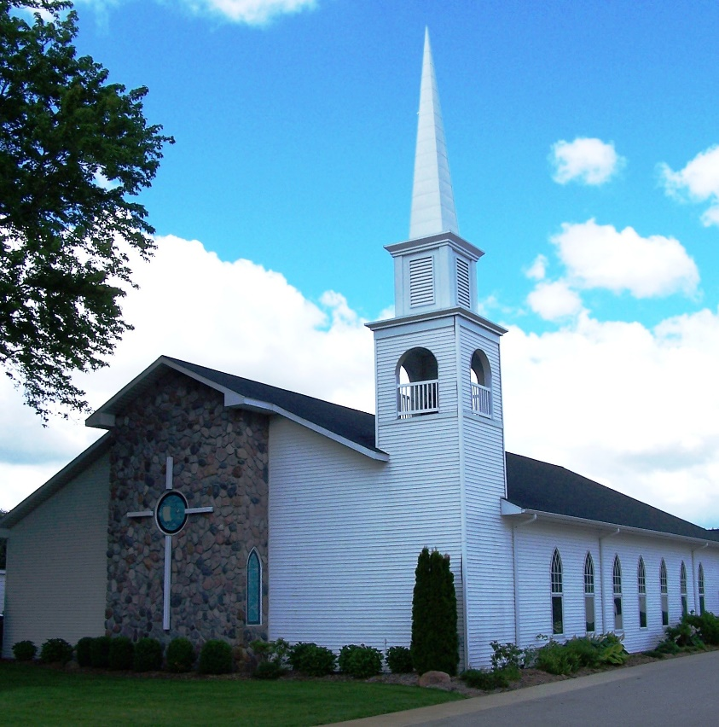

As a part of God’s family
We strive to show Christ’s love to all
For the glory of God

Pastor Les Van Dyke
Pastor Nate Kooistra

